Faiza Abdullah

Lab 01 on MSLE Skillable Platform

ITAI 2376 Deep Learning in Artificial Intelligence

Professor: [Patricia Mcmanus](https://eagleonline.hccs.edu/courses/282423/users/264039)

**REFLECTIVE JOURNAL: EXPLORE AZURE AI SERVICES PORTAL**

**PROOF OF COMPLETION:**

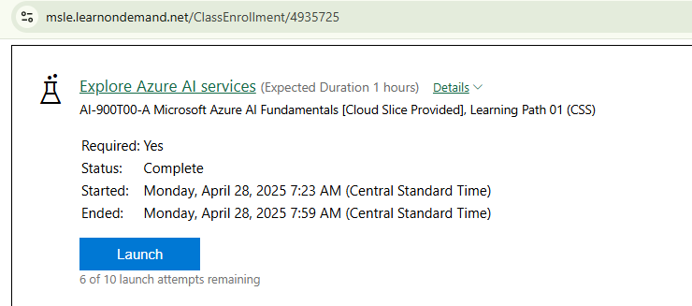

**INTRODUCTION**

This lab explored Azure AI services, with a specific focus on the Azure AI Content Safety service, that enables users to moderate text and image content.

**LAB OBJECTIVES AND PROCESS**

The lab familiarizes with Azure AI services and their applications in content moderation using the Content Safety Studio to test its functionalities.

**WHAT I DID**

* Accessed the Content Safety Studio through the provided URL and associated an Azure AI services resource with the Content Safety Studio. This involved creating a single-service Content Safety resource.

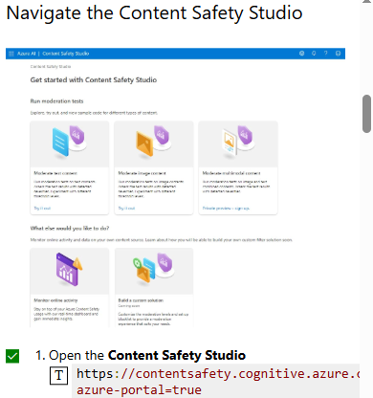

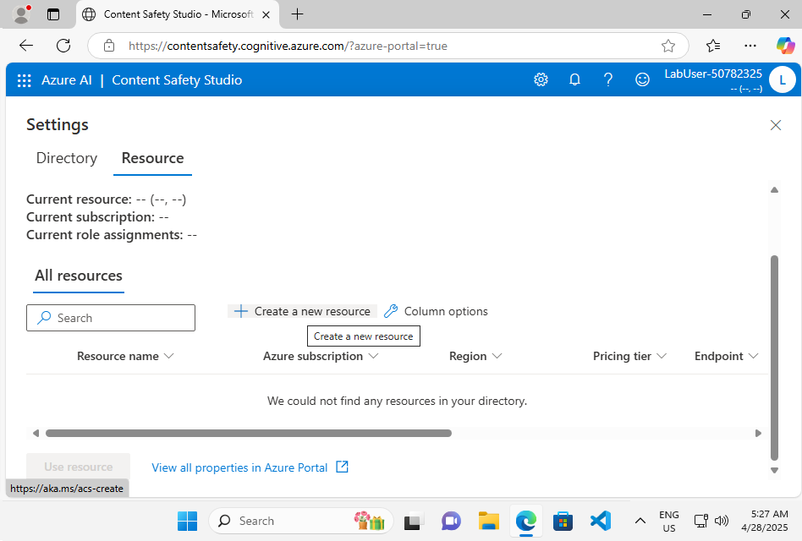

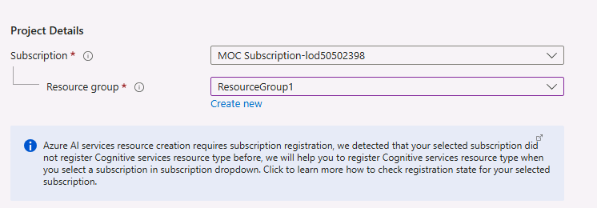

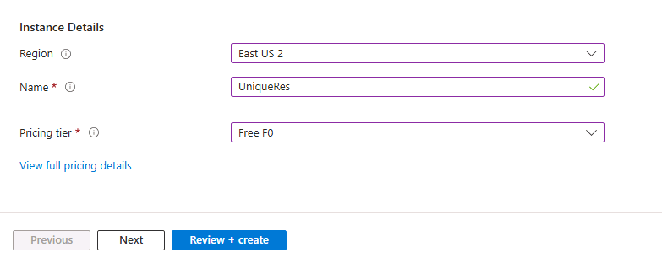

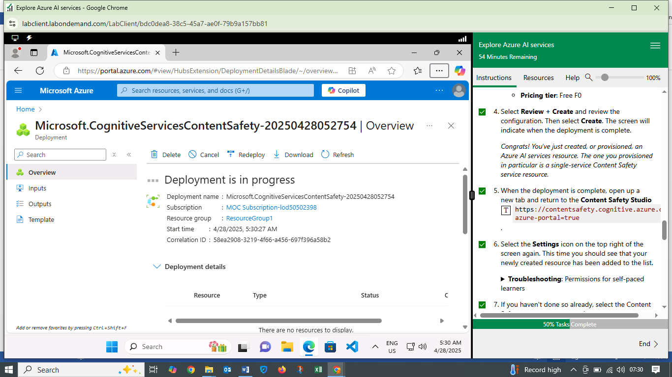

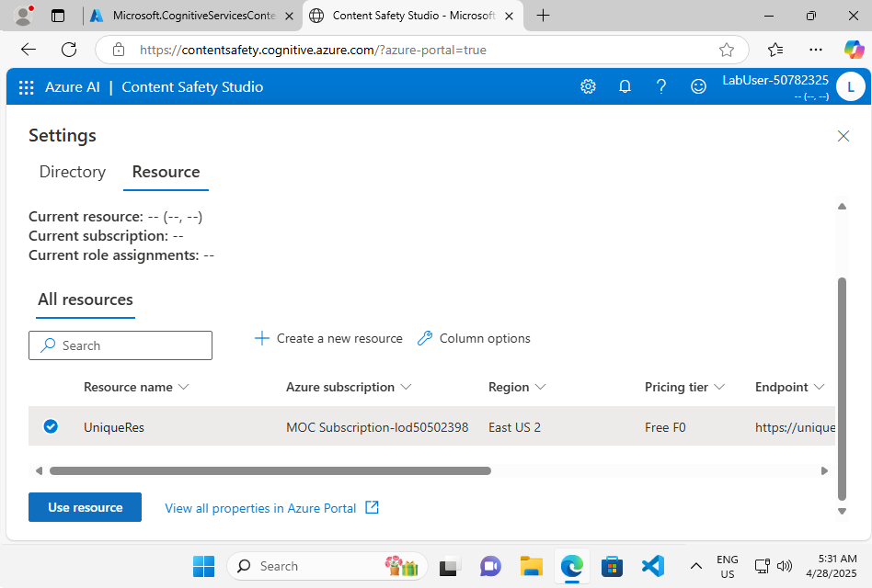

* Used the Content Safety Studio to moderate text content. This involved running tests on sample text and inspecting the results. Firstly used the "Safe content" sample text.

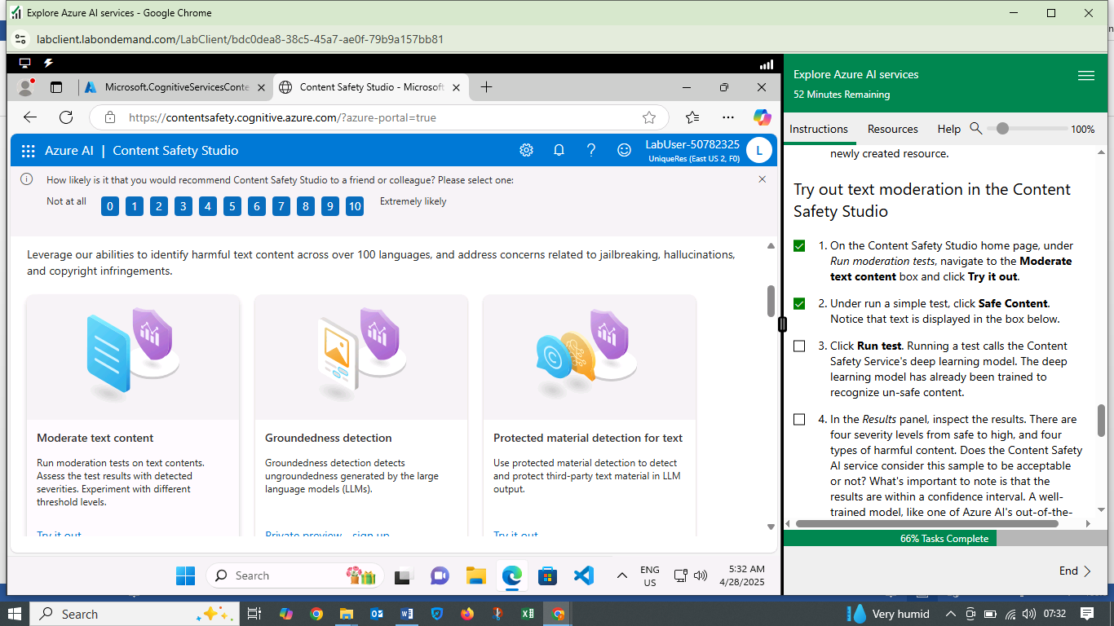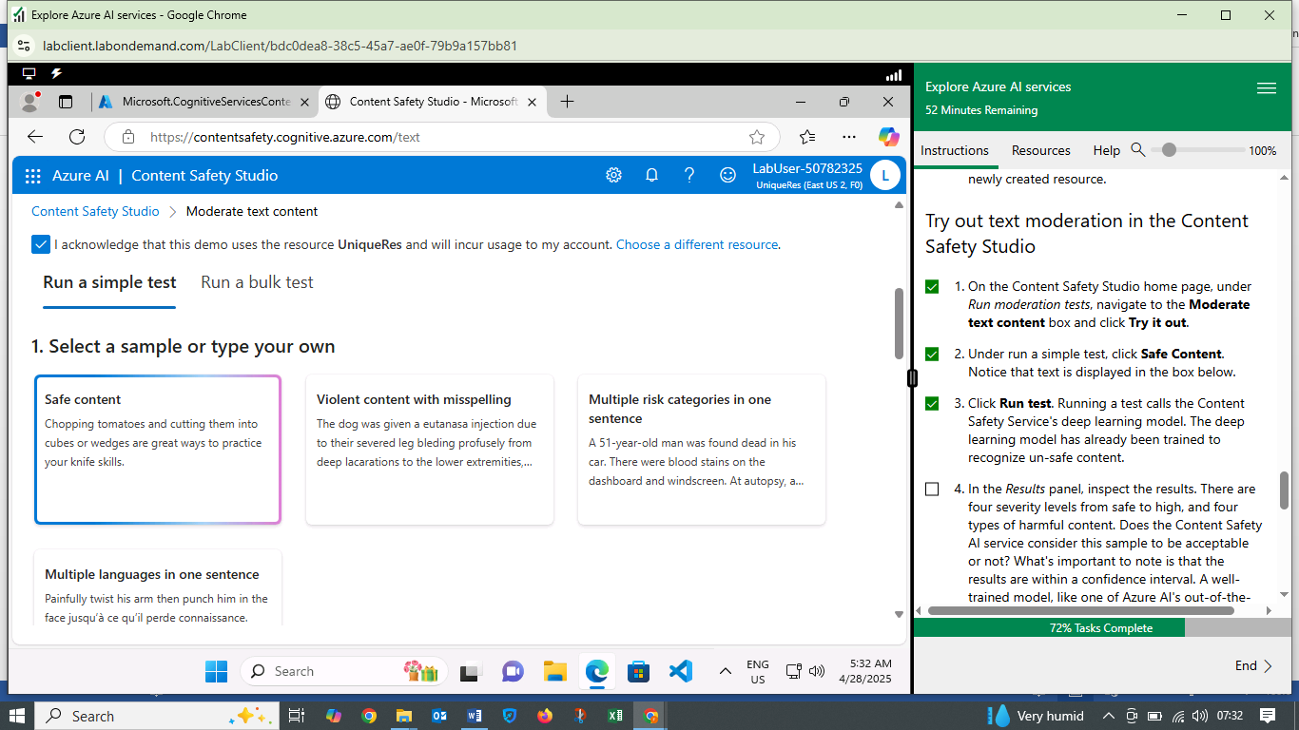

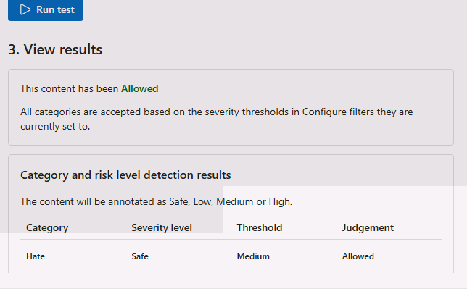

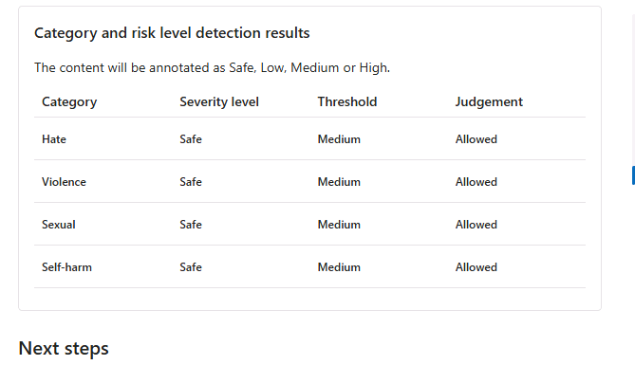

* Then checked Violent content with Misspellings text.

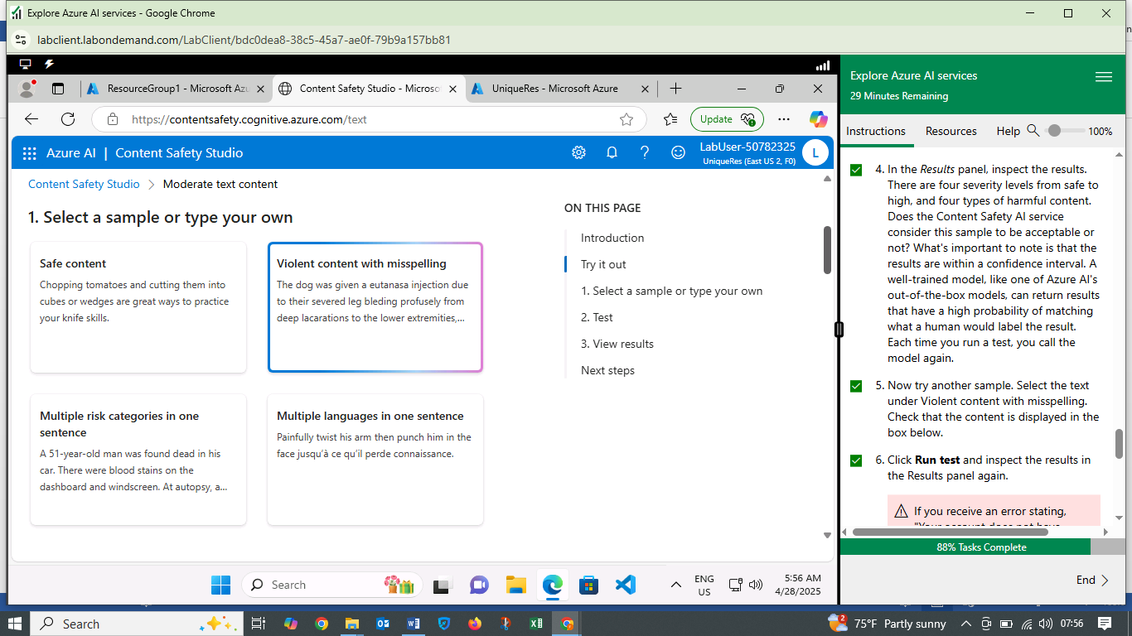

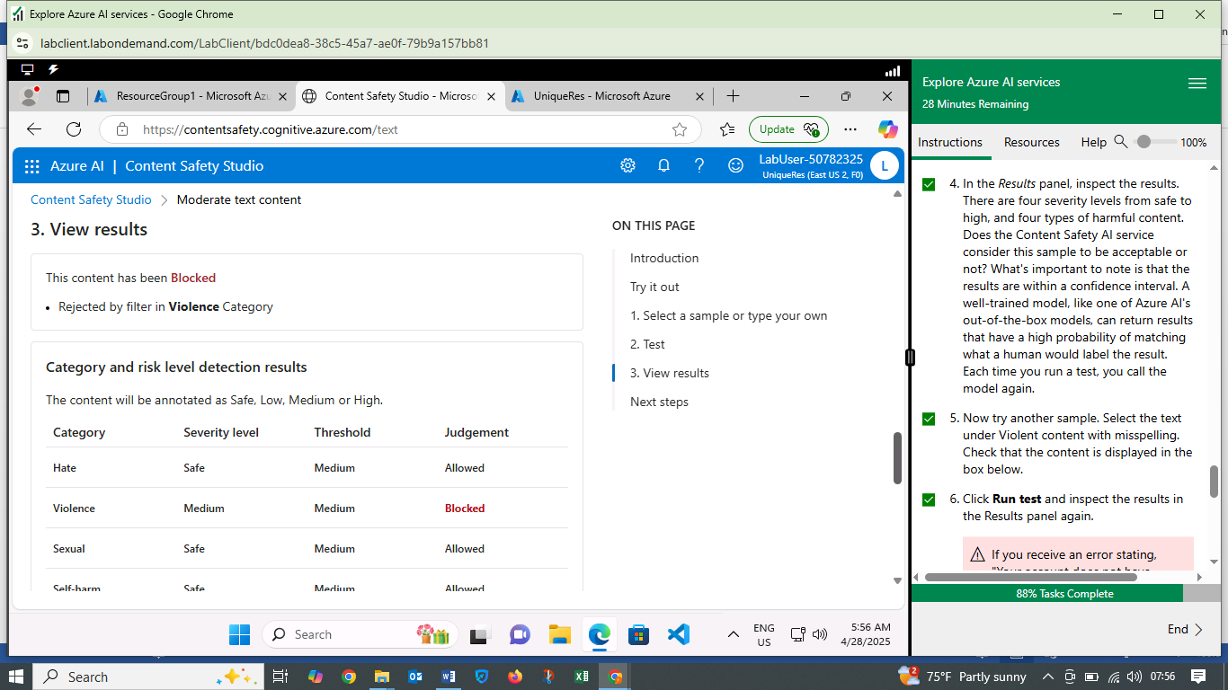

* Finally checked keys and endpoints

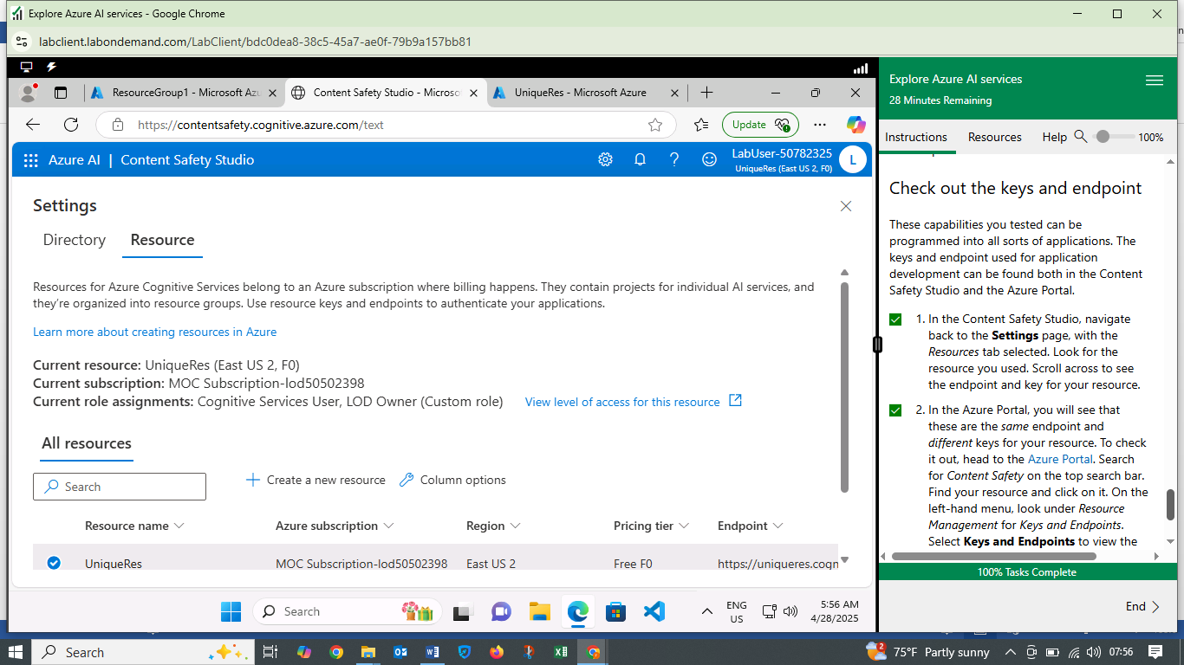

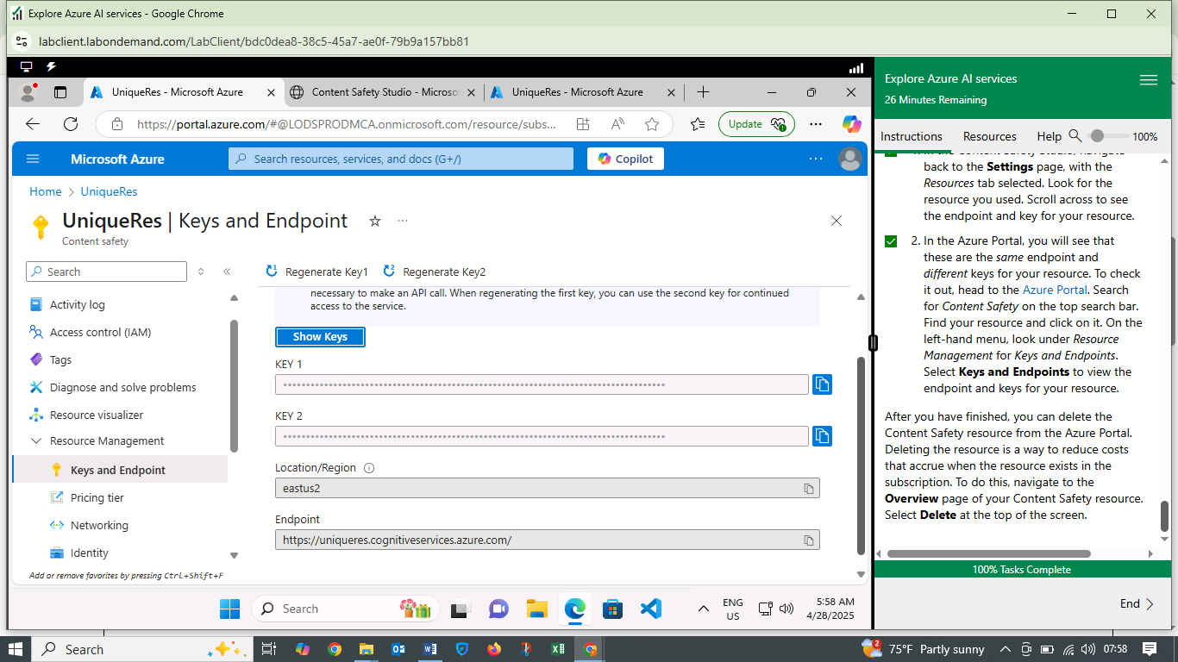

**WHAT I LEARNED**

* Azure AI Services: I gained an understanding of the breadth of Azure AI services and their applications.
* Content Safety: The lab provided insight into the importance of content moderation and how Azure AI Content Safety can be used to detect harmful content.
* Content Safety Studio: I learned how to use the Content Safety Studio to test content moderation.

**CHALLENGES FACED**

* Resource Creation: Creating the necessary resource in Azure required careful attention to the steps to ensure it was correctly configured.

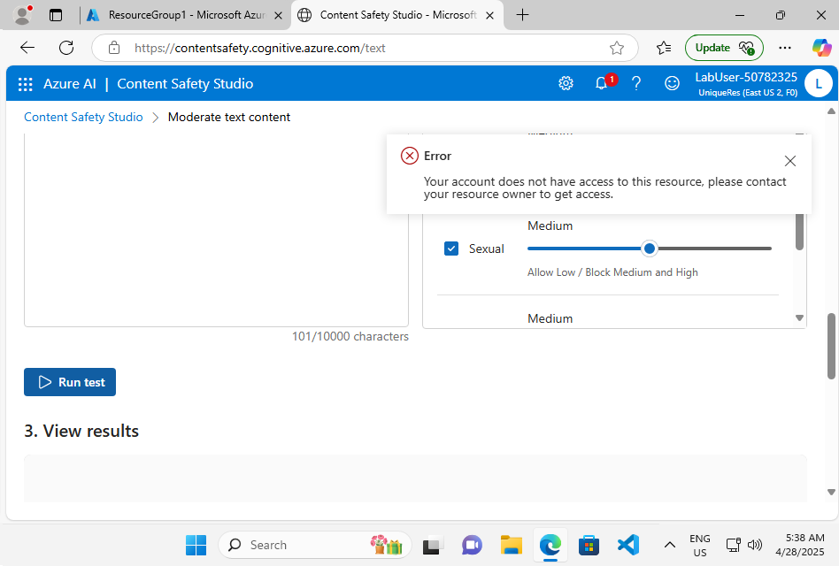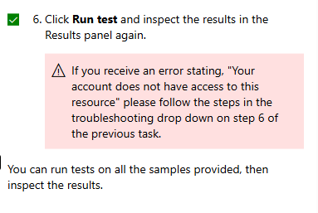

* Troubleshooting process:

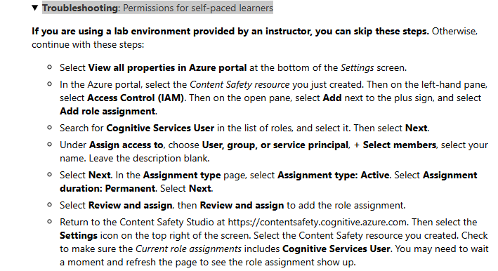

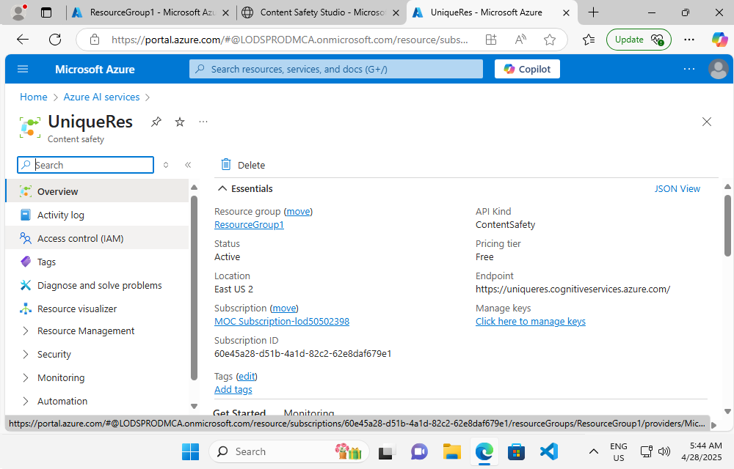

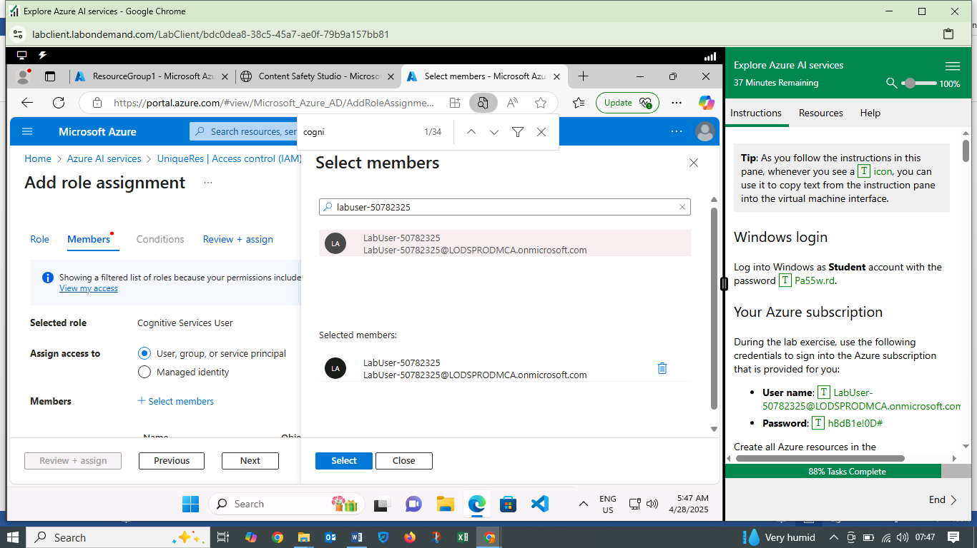

**INSIGHTS GAINED**

* Importance of Content Moderation: Content moderation is crucial for maintaining a safe online environment.
* Azure AI Tools: Azure AI provides tools like Content Safety to help automate content moderation.
* Practical Application: The lab demonstrated a practical application of AI in addressing a real-world problem.

**CONCLUSION**

This first lab on exploring Azure AI services was an eye-opening experience where I navigated the Azure AI Foundry portal, set up a resource, and used the Content Safety Studio.